University of Petroleum and Energy Studies
School of Computer Science
Department of Cybernetics

Graphics & Animation Tools
Viva-1
(Session: 2020-2021)

Course: B. Tech with Specialization in Open Source and Open Standards

Submitted To- Submitted By-
Dr. Durgansh Sharma Rahul Raj Baranwal
Associate Professor SAP ID -500061624
Department of Cybernetics Roll No. -R100217054

Experiment-1 Creation of fruit basket in Blender with a few fruits in it in blender.
In this experiment we need to create a basket with a few fruits of our choice with the help of blender.
Steps to follow to create a 3D design using Blender
- Open Blender, and clear everything from the interface which are already there.
- First, we need to create a basket. For basket go to mesh and take a plane area and then go to mesh again and select a cylinder.
- Stretch the upper face with respect to base of cylinder and give it a shape of open basket.
- Extrude the surfaces from all the sides at equal distance to give it a look of moulded surface of basket.
- Extrude the bottom of the surface around 1.5 pts and give it shape of base of the basket.
- Do a few changes in the model of basket to give it a realistic approach in better ways.
- For apples, take the sphere from the mesh and give it a grouve from above so, that it looks like the upper portion of apple. Now, put some dots on the apple to give it more realistic look.
- Now, take the upper portion of apple and extrude it a bit to give the shape of twig which is attached with the apple.
- Repeat step 7 and 8 multiple times to create a number of apples for the basket.
- Now, go to shading and then random and fill your selected area with random colours.
- Go to file and save it as your name and render a few pictures for the display.

Rendered Picture for reference:

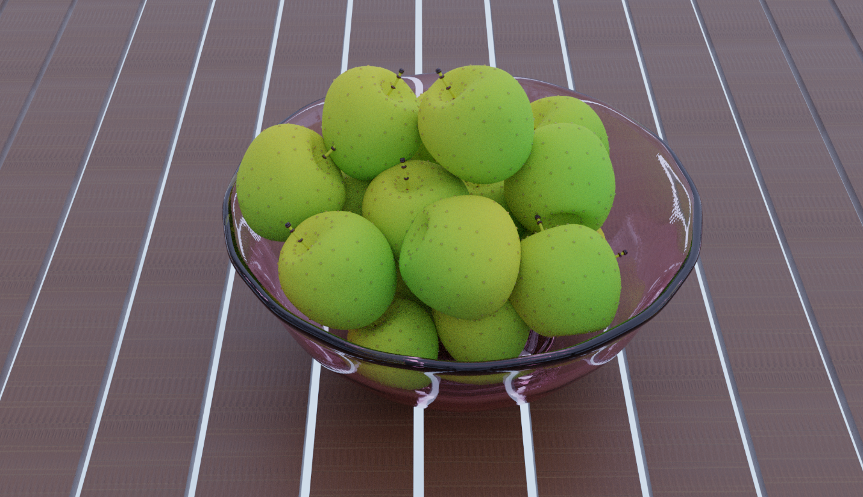

Experiment-2 Creation of basic layout of mobile phone in GIMP.
In this experiment we need to create a basic layout of mobile with added icons of our choice with the help of GIMP.
- Take a white background of 1080 x 580 pixel.
- And put a slightly smaller black ground to create a black border over it.
- Take a small square in the centre to create the shape of a home button.
- Import a few buttons for forward and backward and put it side by side of home button
- Create a basic layout by putting a few buttons and everything to give it a realistic picture of mobile phone.
- Save the output. And export it in other location with .XCF extension

Output Picture for reference:

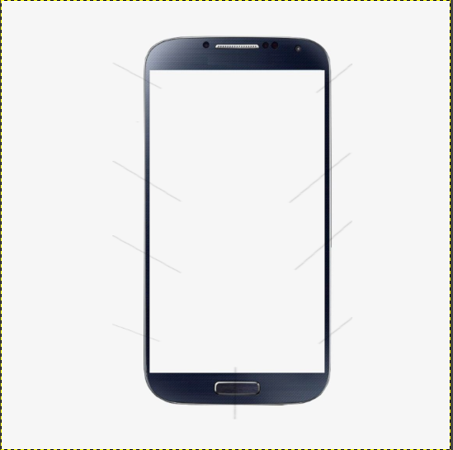

Link of the Experiments:
https://drive.google.com/drive/folders/1zAM0TqdB-oZ51oETh9lZa7Sm6kxjBV_q

